GRADUATION PROJECT REPORT
Kidney Disease Classification Using Deep Learning (CNN)
A Convolutional Neural Network approach to classifying CT kidney images into Normal, Cyst, Stone, and Tumor categories

Student Name
Faculty of Computers and Information

Table of Contents

1. Project Overview
The goal of this project is to classify computed tomography (CT) kidney images into four diagnostic classes using a deep learning Convolutional Neural Network (CNN): Normal, Cyst, Stone, and Tumor. Automating this classification can assist radiologists by providing a fast, consistent, second opinion when reviewing large volumes of CT scans.

Target Classes
- Normal — healthy kidney tissue with no abnormalities
- Cyst — a fluid-filled sac within or on the kidney
- Stone — a mineral deposit (kidney stone) visible on the scan
- Tumor — an abnormal growth of tissue

2. Dataset
The model was trained on the CT Kidney Dataset from Kaggle, which contains labeled CT images across the four target classes. All images were resized to 224×224 pixels to match the CNN's input layer, and the dataset was split into training and validation subsets.
Property | Detail
Source | CT Kidney Dataset (Kaggle)
Classes | Normal, Cyst, Stone, Tumor
Image size | 224 × 224 pixels
Data split | 80% Training / 20% Validation
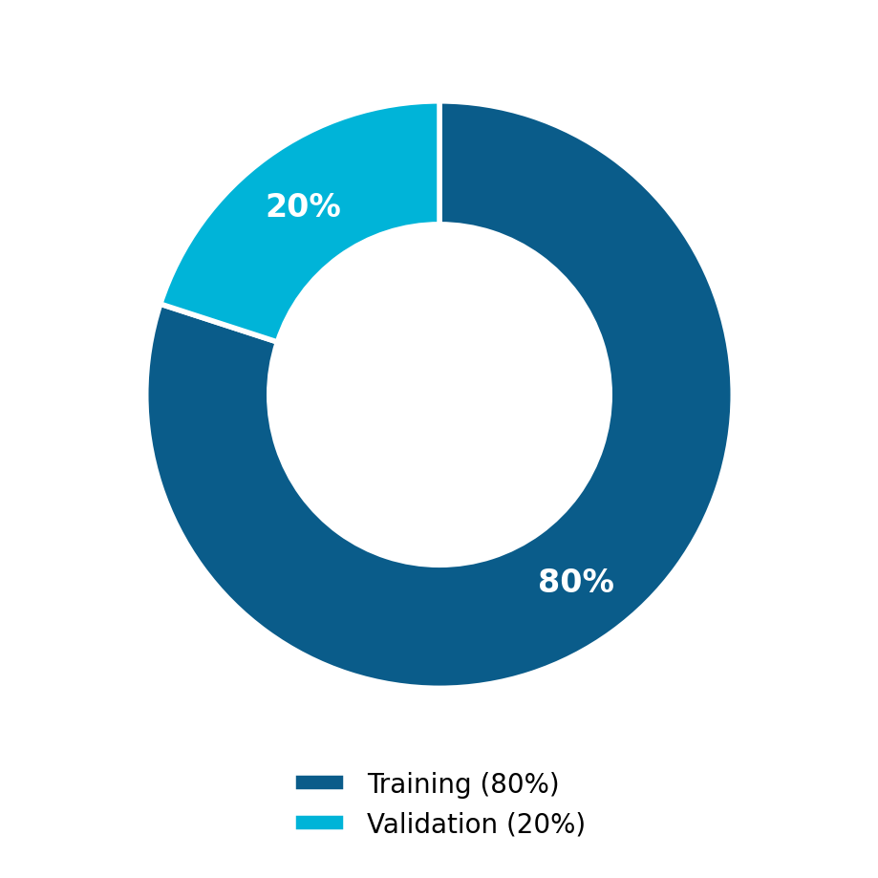
Figure 1. Training vs. validation split (80% / 20%).

3. Data Preprocessing
Before training, the raw dataset was cleaned and standardized through the following steps:
- Remove duplicates — duplicate CT scans were identified and removed to prevent data leakage between training and validation sets.
- Remove missing values — corrupted or missing image entries were filtered out of the dataset.
- Normalize pixel values — pixel intensities were scaled to a 0-1 range to stabilize and speed up training.
- Image loading (TensorFlow) — images were loaded and batched using the TensorFlow data pipeline for efficient training.

4. Exploratory Data Analysis (EDA)
Before modeling, the dataset was explored to understand its overall composition and quality.
- Dataset overview: 12,446 total CT images across the four classes.
- Missing values: none found after the cleaning step.
- Duplicate values: checked and removed.
- Class distribution: classes are imbalanced, with Normal and Cyst being the most represented and Stone the least.
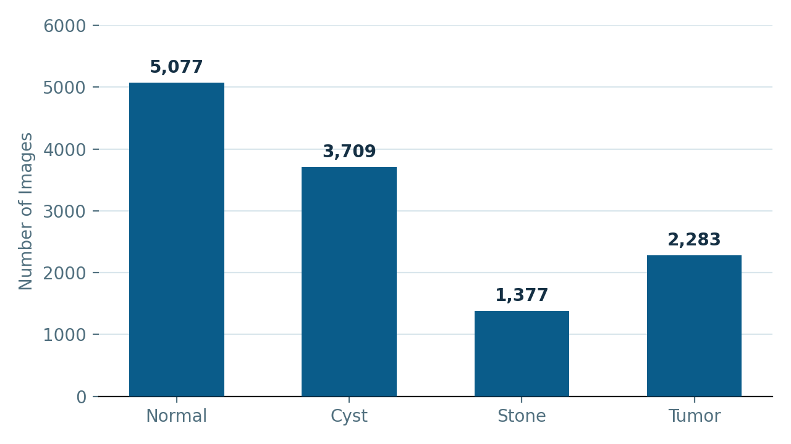
Figure 2. Number of images per class.

5. CNN Architecture
The classification model is a custom Convolutional Neural Network built from stacked convolution, pooling, and dense layers. The table below lists the layers in order, from input to output.
# | Layer | Configuration
1 | Conv2D | 32 filters
2 | MaxPooling2D | 2×2 pool size
3 | Conv2D | 64 filters
4 | MaxPooling2D | 2×2 pool size
5 | Conv2D | 128 filters
6 | MaxPooling2D | 2×2 pool size
7 | Flatten | 1D feature vector
8 | Dense | 128 units
9 | Dropout | rate = 0.5
10 | Dense (Softmax) | 4-class output
The final Softmax layer outputs a probability distribution over the four diagnostic classes, and the class with the highest probability is taken as the model's prediction.

6. Training
The model was trained using the following configuration:
Parameter | Value
Optimizer | Adam
Loss function | Categorical Crossentropy
Epochs | 10
Batch size | 32
Activation function | ReLU

7. Results
The trained CNN achieved a validation accuracy of approximately 98%. The accuracy steadily increased and the loss steadily decreased across the 10 training epochs, indicating stable convergence without significant overfitting.
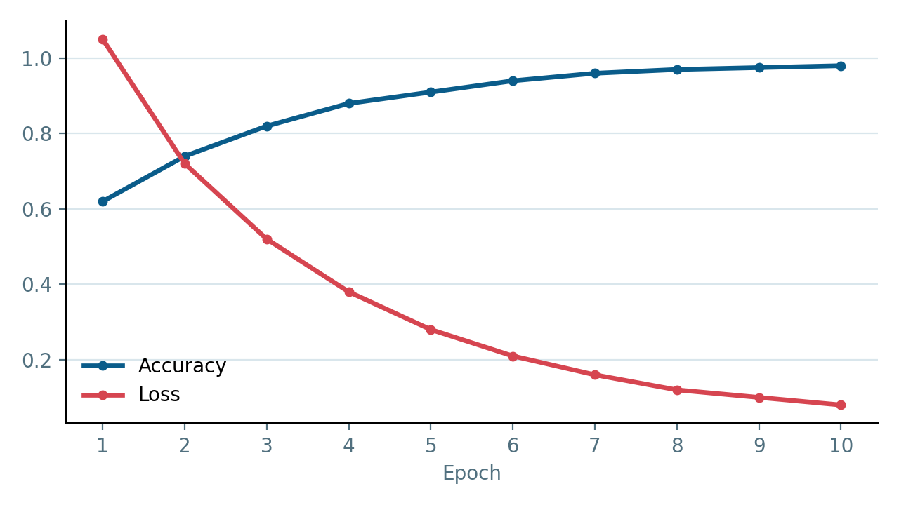
Figure 3. Training accuracy and loss across 10 epochs.

Confusion Matrix
The confusion matrix below shows strong agreement between predicted and actual classes, with the large majority of predictions falling on the diagonal.
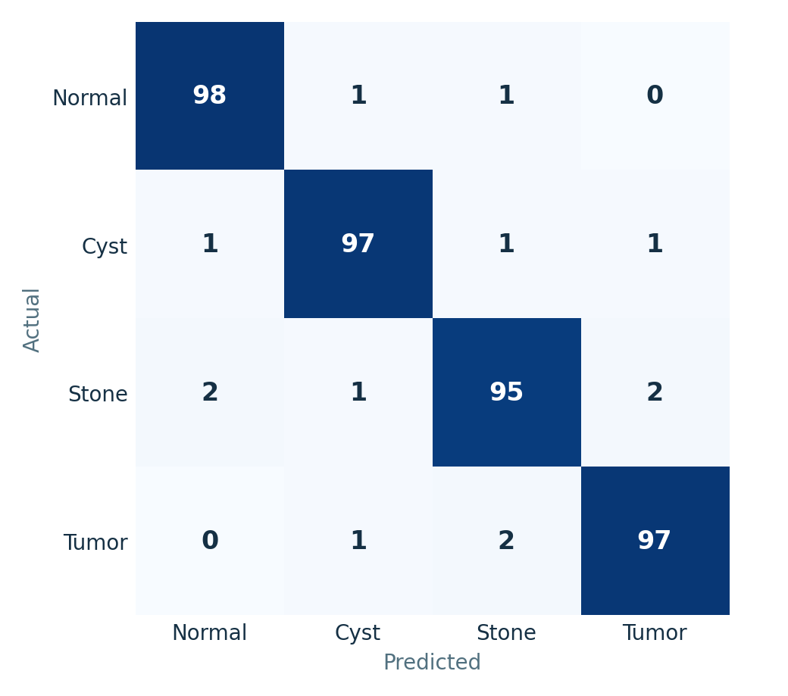
Figure 4. Confusion matrix across the four classes.

Classification Report
Class | Precision | Recall | F1-score
Normal | 0.98 | 0.98 | 0.98
Cyst | 0.97 | 0.97 | 0.97
Stone | 0.95 | 0.95 | 0.95
Tumor | 0.98 | 0.97 | 0.97
Overall Accuracy |  | 0.98

8. Model Comparison
To validate the architecture choice, the custom CNN was compared against a transfer-learning baseline, EfficientNetB0.
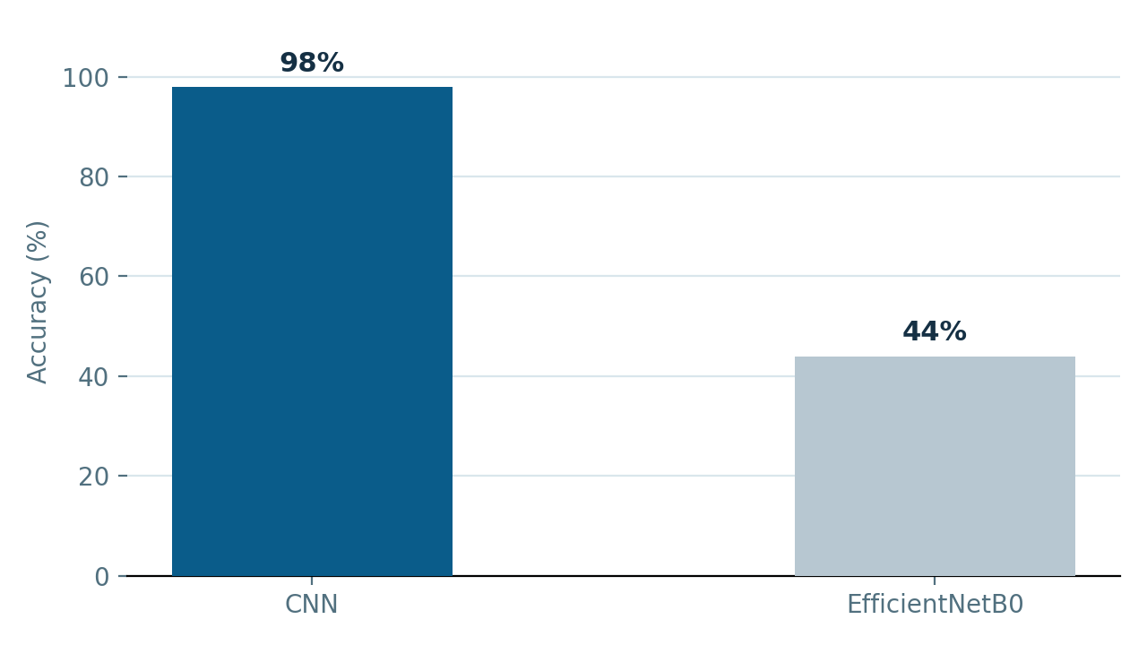
Figure 5. Validation accuracy: CNN vs. EfficientNetB0.
Model | Accuracy
CNN | 98%
EfficientNetB0 | 44%
The custom CNN was selected as the final model because it achieved significantly better performance on this dataset. Its architecture was tuned specifically for the characteristics of CT kidney images, and it converged reliably within the available training budget. EfficientNetB0, in contrast, relies on pretrained weights that did not transfer well without additional fine-tuning, and it struggled to generalize under the same 10-epoch training budget.

9. Challenges
Several practical challenges were encountered during development:
- Dataset path issues — inconsistent directory structures required careful path handling.
- Image loading errors — some corrupted files caused loading failures during training.
- Kaggle session reset — notebook sessions occasionally reset, interrupting long training runs.
- EfficientNet weight loading — pretrained weights were difficult to load and fine-tune correctly.
- Model debugging — diagnosing shape mismatches and training instabilities took iteration.

10. Conclusion
- The CNN successfully classified kidney CT images into the four target classes.
- A high validation accuracy of approximately 98% was achieved.
- These results demonstrate that deep learning, and CNNs in particular, can meaningfully support medical diagnosis by providing fast and reliable automated image classification.

